DLD LAB MANUAL # 04

Purpose of this Lab:
- Max terms and min terms
- SOP and POS
- Conversion between min terms & max-terms.

AND (74LS08)
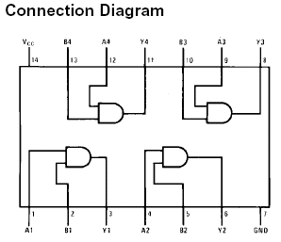

OR (74LS32)
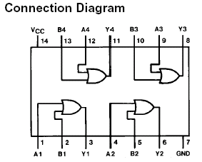

NOT (74LS04)

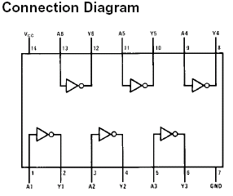

In LAB TASKS

Q1. Convert the following to POS form by using the Distributive law & implement on Logic Works.
xy' + yz'
Q2. Convert the following to POS form by using the De Morgan’s laws & implement on Logic Works.
b′d + ac′d′
Q3. Write the following in SOP form & implement on Logic Works.
- (x'+y)(y'+z) b. (x + y’)(y’+ z)
Q4. For the Boolean Functions E and F:
- List min-term and max-terms of each function.
- Express E and F in sum-of-min-terms algebraic form.
- Implement the E function on Logic works.

X | Y | Z | E | F
0 | 0 | 0 | 0 | 1
0 | 0 | 1 | 1 | 0
0 | 1 | 0 | 1 | 1
0 | 1 | 1 | 0 | 0
1 | 0 | 0 | 1 | 1
1 | 0 | 1 | 0 | 0
1 | 1 | 0 | 1 | 0
1 | 1 | 1 | 0 | 1

Q5. Find Max terms from the following Min terms and write its expression. Also, implement the resultant expression on Logic Works.

F(X,Y,Z) = Σm (1,3,6,7)

Q6. Find Min terms from the following Max terms and write its expression. Also, implement the resultant expression on Logic Works.

F(A,B,C) = ∏M (0,3,4,5,7)

Q7. Find Max terms from the following Min terms. Also, implement the expressions of min terms & max terms (both) on Logic Works.
F(X,Y,Z) =Σm (0,1,2,4,6)

Q8. Find the output expression, truth-table. And also implement on Logic Works:
